Ragger Jonkers - 10542604

Ellen van ‘t Klooster - 10207309

Belle Bruinsma - 10676759

Urscha Fajdiga - 11377437

Edwin Steffens - esteffe1

## **Problem 1: Rainbow color map**

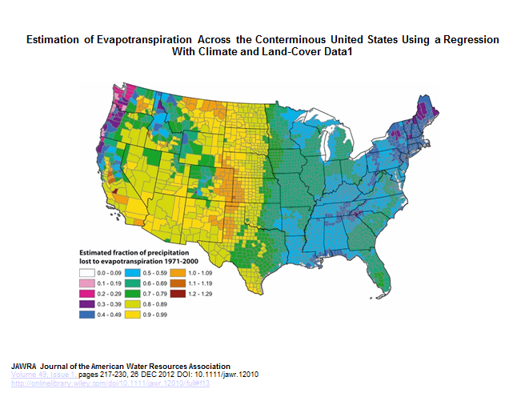Link: <https://betterfigures.org/2015/06/23/picking-a-colour-scale-for-scientific-graphics/>

The objective of the graph above is to show the level of evapotranspiration across the US. The graph has been posted in a scientific journal, namely the *Journal of the American Water Resources Association* (JAWRA). The audience probably consists of scientists and professionals in the water resources sector. In our opinion, the graph is not successful in conveying the information. In the visualization, it seems there is a very clear boundary in evapotranspiration between east and west and that the difference is large. This is due to the sudden transition from yellow to green, which are very different to the eye. In reality and as can be seen in the legenda, the difference between yellow and green is very small. The graph is successful in showing the small differences using this color scheme, however, small differences unjustly seem to be very large in this visualization. Therefore, we would recommend to not use a rainbow color scheme.

## **Problem 2: Patterns and colors in maps**

### Bing Maps vs Google Maps

Bing Maps and Google Maps both have the ability to render buildings in 3D and to rotate the view. However Bing Maps only allows you to rotate a static 90 degrees, while Google Maps allows you to rotate your viewpoint continuously. In addition Google Maps allows you to rotate your viewpoint in 3D (not only turn your head, but also lift it up and down). If you compare the ways of looking for e.g. the Rembrandt Tower entrance, Google wins easily. For the 3D look Bing Maps uses a very distant capture point, making the resolution way lower than Google Maps. In contrast to this, Google Maps has a high definition street view option.

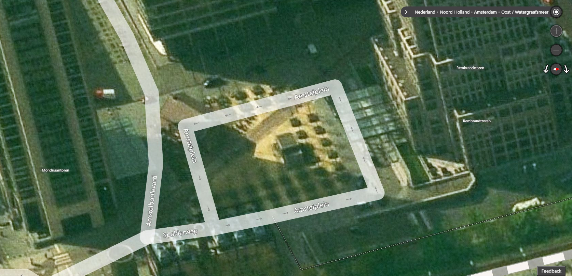

Bing Maps - Rembrandttoren (best possible angle to entrance)

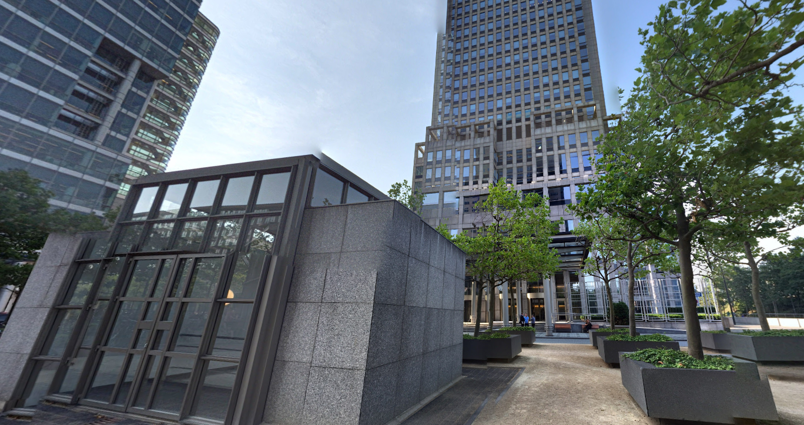

Google Maps (street view) - Rembrandttoren entrance

The biggest flaw in the determining the routes, is that Bing Maps does not have the option to go with bike. The closest alternative is by foot, but some routes to not have bike ways, while you would still be able to walk on the trottoir. Visually the route design are similar. One point of critique on the side of Bing Maps would be that it can be too cluttered with names and routes (using 3D). On the other hand of Google Maps can be said that only those blue dots pointing out the route get lost in the what already is a very blue/grey background. (Could’ve highlighted the route with an additional white uninterrupted line)

See comparison of the same part of the route below.

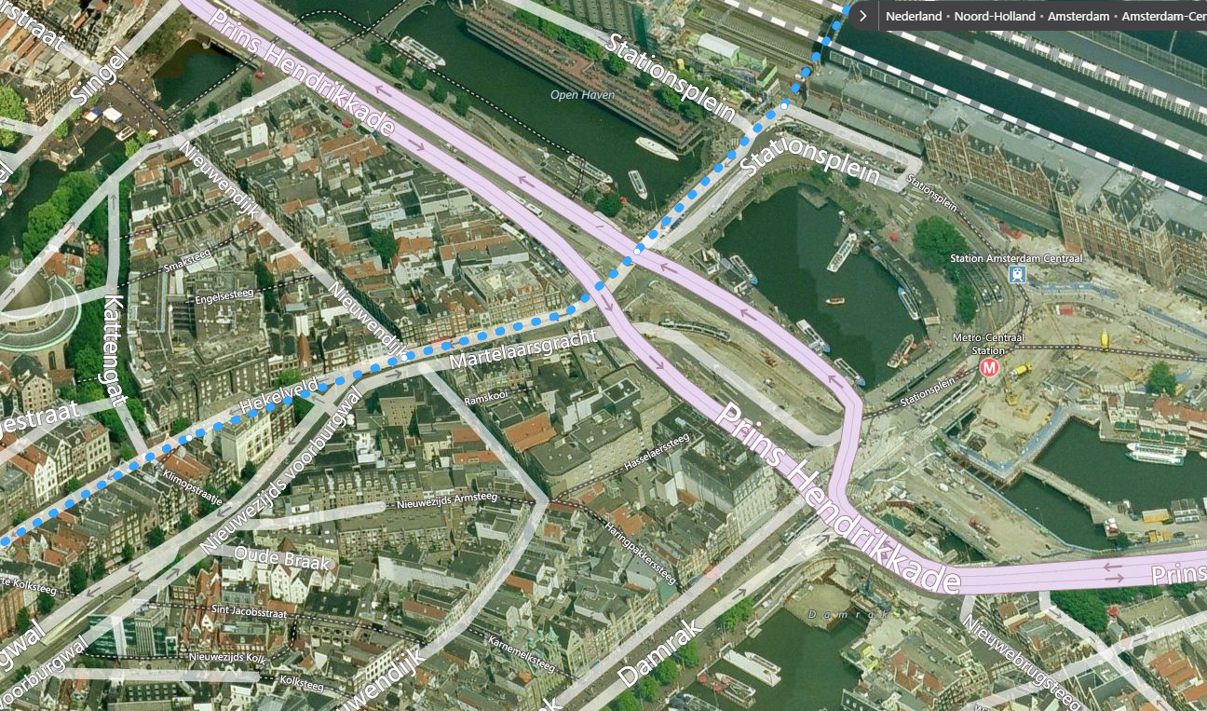

Bing Maps

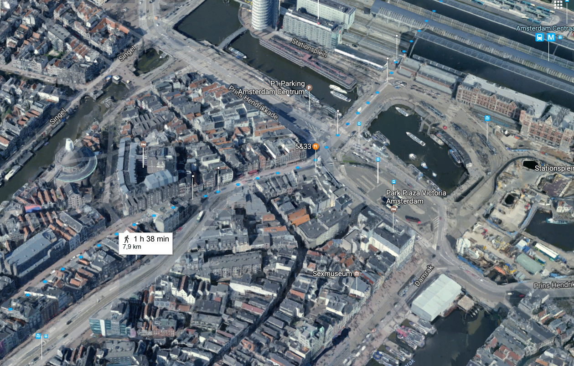

Google Maps

If we quickly summarize the good and bad points about both maps and weigh them out to each other we are able to decide which Maps medium is better to use:

|  |  |  |  |  |
| --- | --- | --- | --- | --- |
|  | **Resolution** | **Building search** | **Routes (3D)** | **Name density** |
| **Bing Maps** | Low | Only 90 degrees rotation, lower responsiveness | Cluttered view,  No bike option | Can be unwantedly high at points, see picture below |
| **Google Maps** | Higher | Continuous rotation + dragging view, higher responsiveness | More minimal, but difficult to see at times | Scales well with zoom level, leaves out most little restaurants at more zoomed out view |

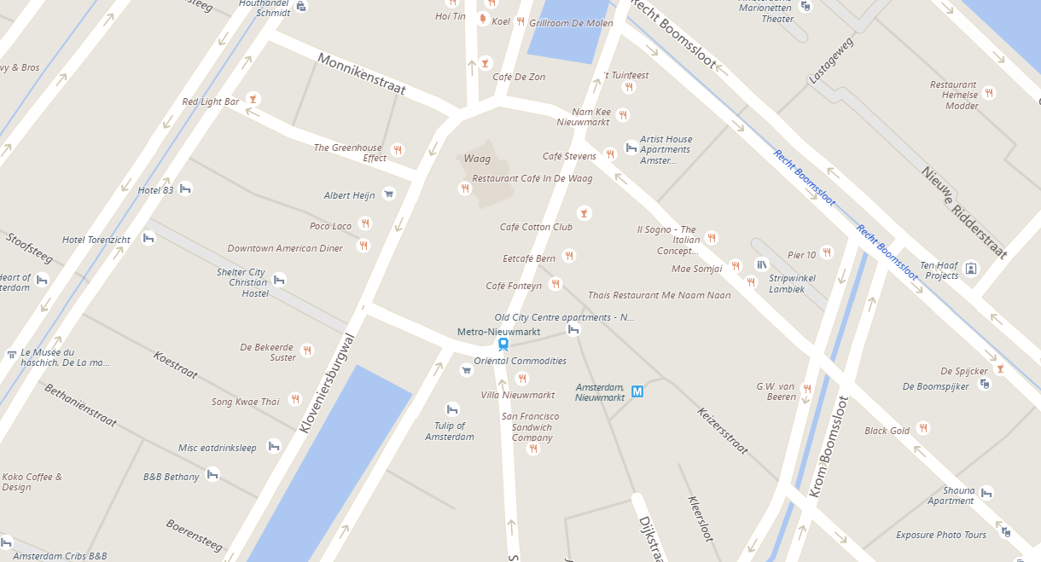

Bing Maps: many (unimportant) names and labels distract you of the names/labels you want to look for.

We think overall Google Maps has done a better job in fulfilling the user’s needs: whether that is to find a building, simply look for random names on the map, or find a route. Bing Maps is not bad, but we would rather use Google Maps.